

**Provisioning Template to Modify Firewall Configuration - Fortigate**

**User Guide**

|  |  |  |
| --- | --- | --- |
| **Version** | **Remarks** | **Date** |
| **1.0** | **Provisioning Template User Guide for Modifying Firewall configuration - Fortigate.** | **27/01/2017** |
| **2.0** | **Updated document with installation of the template.** | **14/02/2017** |
|  |  |  |
|  |  |  |

## Installation of the Template and Helper Script

1. Login to AppViewX.
2. On the left navigation menu, select ***Provisioning***; and click ***Template.***
3. On the upper right portion of the screen click on the  Import button.
4. The following screen will appear. 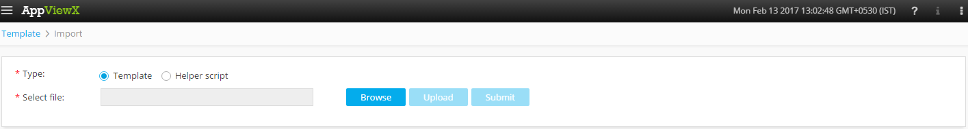
5. Please Select Template/Helper Script.  
   If Template is chosen,
   1. Click on *Browse* and select the Zip File of the template which has to be installed/imported and click open.
   2. Click on upload to import the Zip file and display the templates present in the zip file.
   3. Click on submit to deploy the templates into the AppViewX Environment.

If Helper Script is chosen,

1. Click on *Browse* and select the Zip File of the Helper script which has to be installed/imported and click open.
2. Click on upload to import the Zip file and display the Helper Scripts present in the zip file.
3. Click on submit to deploy the Helper Scripts into the AppViewX Environment.

## MODIFY FIREWALL Configuration.

1. Login to AppViewX.
2. On the left navigation menu, select ***Provisioning***; and click ***Request.***
3. On the upper right portion of the screen, click the  ***Create*** button.
4. Select the provisioning template name from the list –‘**Generic_Modify_Firewall_Rule**’

**Note:** *If no template is available, this indicates that the user role does not have permission to the requesting template.*

1. Enter the provisioning request description – ‘*Modify Firewall Rule*’.
2. Enter the **Request Scenario Name** relevant to the template. ***E.g***.: *Modification of Firewall.*
3. Retrieve the list of **Fortigate** **Devices** available by clicking on the  button and select the required Device.
4. Retrieve the **Device Policies** available by clicking on the  button and select the required policy to modify.
5. Click on **Fetch Config** button to fetch the configuration of the firewall policy.
6. Please choose the option of **Modifying** the *Source Address* (Yes/No).  
   If Yes is selected,
   1. Retrieve the **Source Address** by clicking on the  button and select the Source address.
7. Please select the option of **Modifying** the *Destination* *Address* (Yes/No).  
   If Yes is selected,
   1. Retrieve the **Destination Address** by clicking on the  button and select the Destination Address.
8. Please select the option of **Modifying** the *Action* (Yes/No).  
   If yes is selected,
   1. Please select the action (Accept/Deny).
9. Please select the **NAT**(Network Address Translation)**Protocol** – Dynamic IP Pool/Use Destination Interface Address.  
   If Dynamic IP Pool is selected,
   1. Please select the option of Modifying the IP Pool (Yes/No).  
      If Yes is selected,
      1. Retrieve the **IP Pool** by clicking on the  button and select the required IP Pool.
10. Please select the option of **Modifying** the *Incoming* *Interface* (Yes/No).  
    If yes is selected,
    1. Retrieve the **Incoming Interfaces** by clicking on the  button and select the required Interface.
11. Please select the option of **Modifying** the *Outgoing* *Interface* (Yes/No).  
    If yes is selected,
    1. Retrieve the **Outgoing Interfaces** by clicking on the  button and select the required Interface.
12. Please select the option of **Modifying** the *User* (Yes/No).  
    If yes is selected,
    1. Retrieve the **Source User(s)** by clicking on the  button and select the required Users.
13. Please select the option of **Modifying** the *Device* *Type* (Yes/No).  
    If yes is selected,
    1. Retrieve the **Source Device Type** by clicking on the  button and select the required Device Type.
14. Click on the **Add** to add this scenario. Many other scenarios can be created for this template before submitting the request.
15. Click on *Submit* to generate work order(s) for the provisioning request.